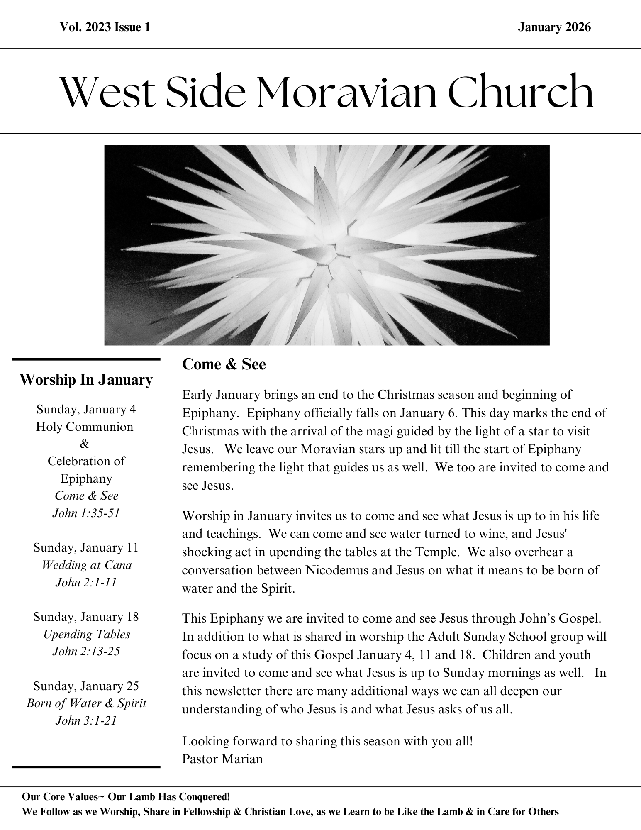

West Side Moravian Church
1707 South Oneida Street
Green Bay, WI 54304
Phone: 920-499-4433 www.wsmoraviangb.org

Church Office Hours:
Monday-Thursday
10:30 am-2:30 pm

Worship Schedule:
Worship followed by Fellowship 9:00 AM
(Elevator Available)

Deadlines:
Newsletter: 20th of the Month
Bulletin: Wednesday each Week

This NEWSLETTER is published 12 times a year and is distributed; free of charge, to those who are interested in our ministry. The staff welcomes your comments, letters, and submissions. One License #A-73096

Easter Blooming Plant Order

If you would like to order an Easter Blooming Plant to help decorate
West Side Moravian Church please, complete this form below and return
it to the church office or place in offertory by Wednesday, April 6th.
The cost for each Easter Blooming Plant will be $15.00. Please make
checks payable to West Side Moravian Church and in memo area note
“Easter Plant.”
In Memory Of or Tribute To (Please circle one.) ___________________________________________________

_____________________________________________________________________________________________________________________________________________

_______________________________________________________________________________________________________

Given By ______________________________________________________________________________________

______________________________________________________________________________________________

______________________________________________________________________________________________

Number of Plants Ordered ______________________ Amount Paid ____________________________________

ANNUAL REPORTS AND CHURCH COUNCIL

Our Annual Church Council will be held Sunday, February 6th
at 10am in person or via zoom. In preparation for this meeting,
we invite ministry groups to submit a brief summary to share with the congregation. Please submit reports by Sunday, January 16th to the church office via mail or email office@wsmoraviangb.org or drop off at the church office. At Church Council we will elect new members of the Board of Elders and Trustees. If you have interest in letting your name stand for nomination, please talk to Pastor Marian or a Board member.

Easter Blooming Plant Order

If you would like to order an Easter Blooming Plant to help decorate
West Side Moravian Church please, complete this form below and return
it to the church office or place in offertory by Wednesday, April 6th.
The cost for each Easter Blooming Plant will be $15.00. Please make
checks payable to West Side Moravian Church and in memo area note
“Easter Plant.”
In Memory Of or Tribute To (Please circle one.) ___________________________________________________

_____________________________________________________________________________________________________________________________________________

_______________________________________________________________________________________________________

Given By ______________________________________________________________________________________

______________________________________________________________________________________________

______________________________________________________________________________________________

Number of Plants Ordered ______________________ Amount Paid ____________________________________

Easter Blooming Plant Order

If you would like to order an Easter Blooming Plant to help decorate
West Side Moravian Church please, complete this form below and return
it to the church office or place in offertory by Wednesday, April 6th.
The cost for each Easter Blooming Plant will be $15.00. Please make
checks payable to West Side Moravian Church and in memo area note
“Easter Plant.”
In Memory Of or Tribute To (Please circle one.) ___________________________________________________

_____________________________________________________________________________________________________________________________________________

_______________________________________________________________________________________________________

Given By ______________________________________________________________________________________

______________________________________________________________________________________________

______________________________________________________________________________________________

Number of Plants Ordered ______________________ Amount Paid ____________________________________

2023 Moravian Daily Texts Order Form

______ Paperback (No Directory) ~ $12.00 ______ Paperback (With Directory) ~ $18.00

______ Large Print Paperback (No Directory) ~ $14.00 ______ Large Print Paperback (With Directory) ~ $20.00

______ Hardcover (No Directory) ~ $16.00 ______ Hardcover (With Directory) ~ $21.00

______ Journal (No Directory) ~ $17.00 ______ Journal (With Directory) ~ $24.00

______ Directory & Statistics ~ $8.50 _____________________________ Total Amount Due
(all prices through church include shipping)

To order your 2023 Daily Texts fill out order form and send into the church, you may also call or email the church office with your order. Payment for daily text should be sent in along with your order, if paying by check make it payable to West Side Moravian Church. Orders and payments are needed in the church office no later than Wednesday, August 10th, 2022, any orders after this date you will need to place your order on the Moravian website. Daily Text should arrive to the church in November, you will be contacted when you can pick them up.

Name _______________________________________________________________________________________

Address _____________________________________________________________________________________

Email _____________________________________________________ Phone ____________________________

Office Use Only: Payment Method __________________________________________ Date _______________________

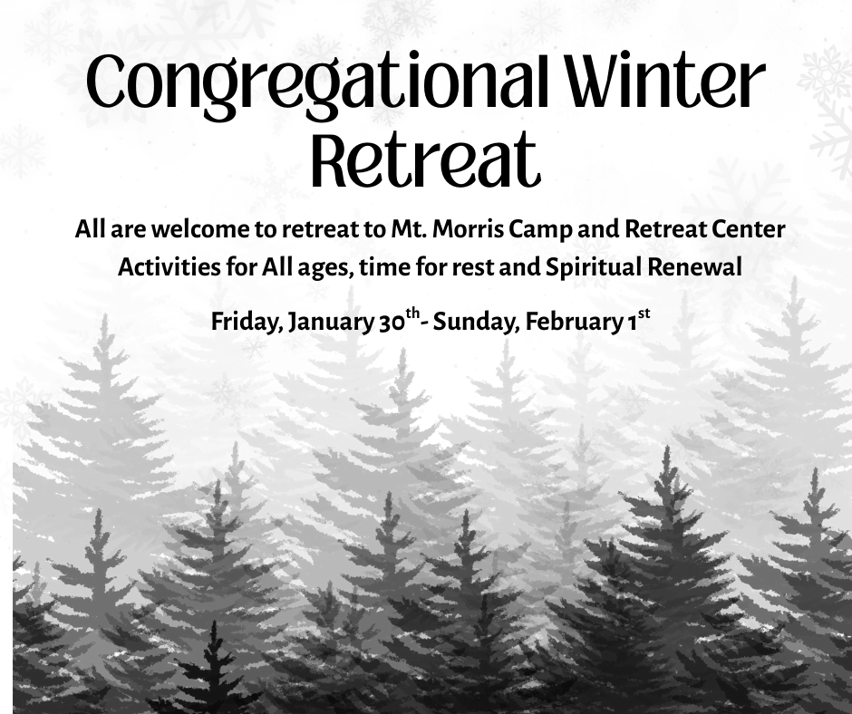

2023 Moravian Daily Texts Order Form

______ Paperback (No Directory) ~ $12.00 ______ Paperback (With Directory) ~ $18.00

______ Large Print Paperback (No Directory) ~ $14.00 ______ Large Print Paperback (With Directory) ~ $20.00

______ Hardcover (No Directory) ~ $16.00 ______ Hardcover (With Directory) ~ $21.00

______ Journal (No Directory) ~ $17.00 ______ Journal (With Directory) ~ $24.00

______ Directory & Statistics ~ $8.50 _____________________________ Total Amount Due
(all prices through church include shipping)

To order your 2023 Daily Texts fill out order form and send into the church, you may also call or email the church office with your order. Payment for daily text should be sent in along with your order, if paying by check make it payable to West Side Moravian Church. Orders and payments are needed in the church office no later than Wednesday, August 10th, 2022, any orders after this date you will need to place your order on the Moravian website. Daily Text should arrive to the church in November, you will be contacted when you can pick them up.

Name _______________________________________________________________________________________

Address _____________________________________________________________________________________

Email _____________________________________________________ Phone ____________________________

Office Use Only: Payment Method __________________________________________ Date _______________________

Our Lamb has Conquered, We Follow as we Worship, Share in Fellowship & Christian Love, as we Learn to Be Like the Lamb & in Care for Others.



ELECTRONIC SERVICE REQUESTED

Non-Profit Organization
U.S. POSTAGE

PAID
Green Bay, WI
Permit No. 42



January Birthday’s
Megan Hanson
William Kamps
Clayton Schenk
Jesse Wiltzius
Lori Hoffman
Dexter Paral
Cheryl Weber
Robyn Marler
Matthew Sadler
William Sadler
Dana Marler
Julie Christianson
Amy Beaumia
Nick Smith
Berri West
Art Hanson


January Anniversaries
Stephen & Robyn Marler

The January Newsletter Sponsored
In Memory Of

Schlader Family

From
Dale & Mary Schlader

Elder of the Month
Board of Elders
Pastor Marian Boyle Rohloff
(Chair)
Sue Vande Hei
Jackie Frelich
(Secretary)
Jim Huss
(Vice-Chair)
Shelley Krueger
Mary Schlader
(Secretary)
Faith Hagedorn
Ivy McGee
Tenna Derenne
(Youth Elder)

Board of Trustees
Shane Krueger
Gary Straughan
Bruce Deuchert
(Chair)
Cal Pashouwer
Dale Schlader
Gary Vande Hei
(Vice- Chair)
Cheryl Weber
(Secretary)

Treasurer
Gary Straughan

Pastor
Rev. Marian
Boyle Rohloff
Office: 920-499-4433
Home: 920-544-8141
(Day off – Friday)

Office Coordinator
Janice Charles Pedler

Organist &
Choir Director
Jason Pues

Custodian
B.J. Derenne

Cemetery Groundskeepers
Gary & Lisa Konshak

Every month a different member of the Board of Elders serves as “Elder of the Month”. They help prepare Holy Communion often assisting with serving. They are another point of contact to reach out to if the Pastor is unavailable or away. They welcome guest worship leaders, and assist with worship as needed.
Elder of the Month for January

Mary Schlader

Church Council
Sunday, January 25th
The Annual Church Council meeting will be held after worship on Sunday, January 25th. This meeting is a gathering to review 2025 ministries, elect leaders for 2026, approve a budget for 2026 and plan for the new year. All are invited to attend though confirmed members are voting members of Council.

If you would like to submit a report for the 2024 Annual Report please do so by Wednesday, January 7th.

Annual Reports will be available starting Sunday, January 11th.


Remembering
Carol Marcks
Carol Marcks entered into the more immediate presence of our Lord on December 4th. A celebration of her life was held in our sanctuary on her birthday, December 23rd. We are grateful for the life of our dear friend in Christ, her service in our church community, and her witness of follow Christ in faith, love and hope.

Our Online Community
If you are interested in joining in worship as a part of our online community, we invite you to join us Sundays at 9am on our Facebook livestream. Go to @westsidemoraviangreenbay/facebook. If you would like books of worship to use at home, or paper orders of worship emailed or mailed to you please contact the church office.



Christian Education News
Sunday school is held every Sunday at 10:15am to 11:15am. Adults meet in the lounge and in January studying the Gospel of John. The Children/youth are downstairs in their meeting rooms. Sunday school for the youth/children is exciting and full of fresh ideas to learn God’s message. In January we will learn what is so special about Jesus’ dedication and baptism. Later in January we will enter into a new Messy Church curriculum “Fill A Bucket”. Come and find out what we will fill the bucket with!!!

Thank you for all of the donations to the Giving tree for “You Belong”. Your thoughtfulness is heartwarming and very much appreciated.

Congregational Retreat will be held in the beautiful Sandhill building at Mt Morris on Friday, January 30-Sunday, February 1, 2026. Come for one day or all days. Still room, so please sign up on the bulletin board.

Next CEC meeting will be held January 6, 2026 at 6pm on Zoom.

Book Discussion
Racial Justice and Understanding
We invite you to discuss the book “Awaken the Sacred: Healing with Traditional Lakota Knowledge, Quantum Physics and the Divine” by Basil Brave Heart. Our discussion will be Wednesday, January 7th at 6:30pm in person and via zoom.

Music Ministries Updates
Thank you to our choirs and musicians for their leadership in worship through 2025! Thank you to our Choir Director, Jason Pues.

Choir members and their families are invited to a Christmas Choir Party on Wednesday, January 14th at the Rite Place. 5pm social gathering and dinner at 6pm.

As we move into 2026 practices will resume on Wednesday, January 21st with Hand Bell Choir at 5pm, Vocal Choir at 5:45pm.

Men’s Fellowship Breakfast
All men are invited to meet for breakfast on the first Saturday of the month. This month the group meets on Saturday, January 3rd at 7:30am at Village Grille in Allouez.

Before You Go Workshop
Have you wrote your own Moravian lebenslauf (a memoir)? Do you have a will or know how to develop such a document? What hymns, scriptures and other plans do you have for your funeral? These questions and more will be addressed in the “Before You Go” workshop offered by the Elders.
Join us Sundays February 22, March 1 and March 8 during the Sunday School hour. On Sunday, March 1 Chris Spaugh from the Moravian Ministries Foundation will be joining us to share what services the Foundation can offer in planning.

Mark your calendars now and see Jackie Frelich or Sue Vande Hei with any questions.

Scrip Gift Card Fundraising

One of our congregation’s fundraising efforts is through Scrip Gift Cards. This is a way for you to support our ministries by purchasing gift cards for your everyday purchases such as groceries, restaurants, clothing and entertainment.

We will be placing an order for cards on Sunday, January 4^{th.} If you would like specific cards, please let us know by this date. Go to
https://shop.shopwithscrip.com/Shop/Product/Browse to see what other retailers are available. Talk to Kailyn Schlader or Pastor Marian with any questions.

Thank you!
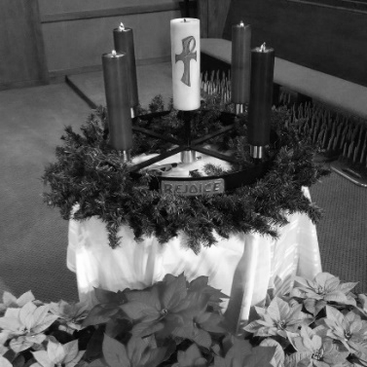
Our congregation is incredibly blessed by the many people serving others in the spirit of Christ Jesus!

Thank you to all who helped make this Advent and Christmas season so meaningful! Thank you to our musicians, candle makers, Sunday School, helpers folding bulletins, those preparing the building and sanctuary for worship, our Boards and Christian Education Committee for their leadership, and all who lifted up the gift of worship to Christ our Lord.

Supporting Our Shared Ministries

Our funding comes from the generosity of people who are committed to this shared ministry.

Your giving strengthens our care for others, cultivates lives marked by generosity, and gives life to Christ’s ministry in worship, learning, service and justice.

You may share your tithes and offerings in worship, by snail mail, or sign up for online giving at https://mmfa.info/west-side-moravian-church-wi-donation-form/ or using the QR code above.

Ecumenical Partnership For Housing
As part of the Ecumenical Partnership for Housing (EPH) our congregation shares in work to provide stability for families moving out of homelessness.

Many thanks to all who gave to EPH in November. $1484.40 was given by people in our congregation and matched as part of EPH’s Giving Tuesday campaign.

Thank you for your generosity and if you would like to be involved in other ways please talk to our EPH Board Member, Julie Srenaksi or our EPH Volunteer Coordinator, Barb Shiffer.

Crafter and Caring Ministry
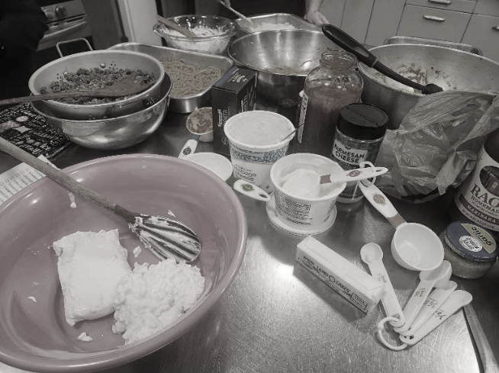
The Crafter and Caring ministry will not meet in January due to the first Thursday falling on New Year’s Day. Our gatherings resume February 5th.
In December we continued to make meals. We made freezer meals to feed 40 people at the St. John the Evangelist Women’s shelter. We also stocked our freezer with individual meals for guests who stop by in need of a meal.

We continue to make prayer shawls and are excited to have you join us in February for crafting, cooking and more ways to care for our communities. See Kris Nelson with any questions or to get more involved.

The Fridge
The Fridge is a mutual aide project we are embarking on with the Lombardi Nieghborhood Association. We would host the refrigerator on our grounds and together with our larger neighborhood keep it filled. We are currently seeking volunteers to help monitor the fridge on a rotating basis. If you have interest talk to Pastor Marian.

Thank you Packer Parkers!
In rain, sun and snow our volunteers were greeting guests utilizing our parking lot before home Packer games. Thank you to all who served parking cars, hall monitoring, selling crafts or selling brats and hot dogs. These funds support various ministries in our congregation.

We were especially grateful to have funds from the last home game of the season go to the Moravian Board of World Mission for disaster relief efforts after storms this Autum in Alaska and Jamaica.
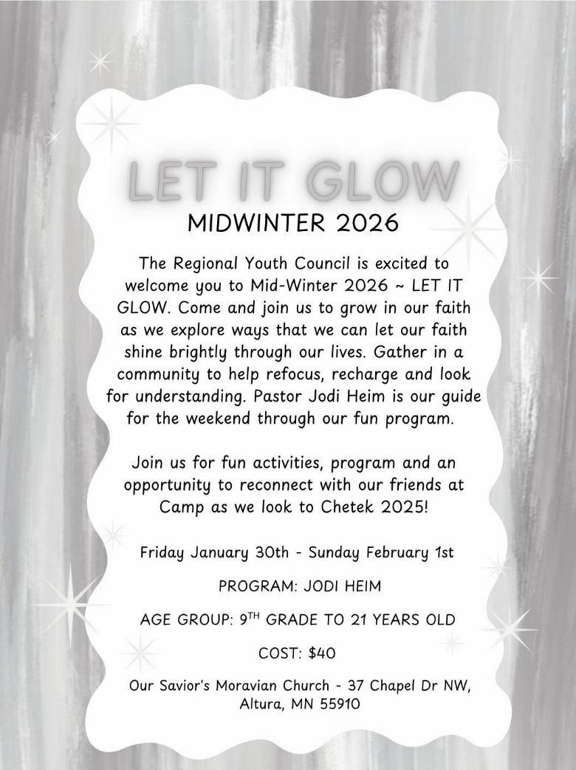

JOSHUA Updates
Our congregation shares justice ministry as part of JOSHUA. Below are upcoming meetings and fundraising opportunities.

Fundraisers:
Papa John’s Fundraiser taking place on New Year’s Eve. Dine in, pick up or delivery from East Mason St. location and 15% goes to support JOSHUA.

Join Chef Champion for an unforgettable culinary experience on January 15 from 10am-1pm. This is at West Moravian. Register and pay in advance by going to joshua4justice.org.

Monthly Meetings:
Prayer Vigil: Tuesday, January 23rd at 12 PM, GBCI on Webster Ave
Housing: Thursday, January 8th at 11 AM, Kavarna
Spiritual Leaders Caucus: Thursday, January 8th at 12 PM, St. Paul's United Methodist
Transformational Justice: Thursday, January 22nd at 6 PM, West Side Moravian Church
Environmental Justice: Wednesday, January 28th at 3 PM, Location TBD
Endowment Fund
What Is The Endowment Fund?

Initiated by the West Side Moravian Church Council in 2003, “the purpose of the Fund is to enhance the mission outreach of West Side Moravian Church beyond the general operation of the congregation.”

How Does The Fund Grow?
Money is given to the Fund and invested through the Moravian Common Fund. Once the fund has received gifts totaling $50,000.00, each year the interest income (limited to 5% of the principle with gains realized in excess of 5% being added to the principle of the account) will be distributed to various causes as recommended by the Endowment Committee and determined by the Joint Board. The Fund will continue to receive gifts to increase the principal so that more income is available for distribution. None of the principle may be spent.

How May I Give To The Fund?
You may give to the Fund through cash gifts, on a weekly, monthly, or annual basis, transfer of securities (stocks and bonds), wills, estate gifts, memorials, or by naming the church as a beneficiary to life insurance policies and annuities. Any gift, large or small will help realize the purpose of the Fund. All gifts are tax deductible to the extent allowable by law.

How Will The Money Be Used?
Members of the Endowment Committee will research the needs and opportunities of the local church, the community in which our church ministers and the Moravian Church at large. The money will be used for community service, outreach, and for providing for the wider mission of the Moravian Church in the U.S. and globally. Each year, the Committee will seek to balance the needs and ministries with funds available. None of the disbursements may go to support the local operating budget of the church.

Thank You To All Who Have Given To The Endowment Fund!

Interested in Giving? For more information, contact members of the Endowment Committee: Pastor Marian, Ray Shiffer, Mike Berken, Gloria Bauder, Cheryl Weber and Mike Schlader.

Thank You From the Mission Team
The Mission Team would like to thank all of you who volunteered in “Chuck’s Brat Shack” this past Packer season. Your help and dedication is always welcomed.

We would like to thank Glenn Tarkowski and his sidekick Fern. Glenn made many updates to “Chuck’s Brat Shack” this past season. He insulated the interior, added needed shelves, hooks, a clock, stools and cup holders, designed a movable condiment stand, and a shelf that goes by the window so customers can put their items down while they pay. Most recently he designed a sign board that directs our Parking and Brat customers to the Restrooms and Brat Shack. Glenn also showed up for every game, cooked our brats and hot dogs, and supplied us with LOTS of charcoal and laughter! We really appreciate your time and talents! Let’s see what Glenn comes up with for the next football season!
Thank you to Shelley Krueger for creating all of our wonderful signs and to Shane Krueger for coming up with great ideas, grilling, and supporting us!!

Most of all thank you to our congregation for supporting missions in many different ways!

- Julie Srenaski & Nancy Knapton

